1. **(a) Write a program in assembly language to print the numbers from 0 to 9.**

**//CODE//**

ORG 100h ; Set origin for COM file

MOV CX, 10 ; Loop counter for numbers 0 to 9

MOV AL, '0' ; Start with ASCII value of '0'

PRINT_NUMBERS:

MOV DL, AL ; Move current number to DL for output

MOV AH, 02h ; DOS interrupt to display character

INT 21h ; Call DOS interrupt

INC AL ; Increment AL to the next ASCII character

LOOP PRINT_NUMBERS ; Loop until CX is zero

MOV AH, 4Ch ; DOS interrupt to exit program

INT 21h

**//OUTPUT//**

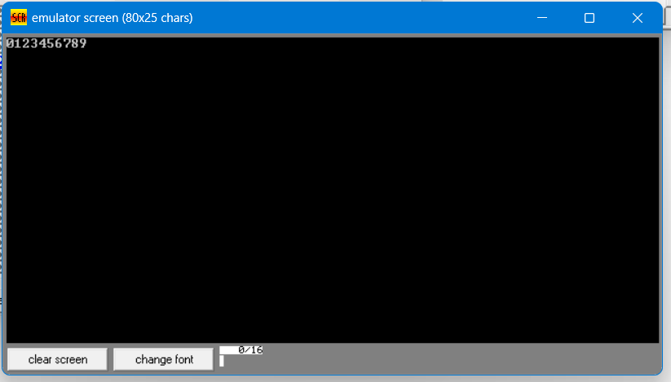

**(b) Write an assembly language program to print the characters from A to Z in reverse order.**

**//CODE//**

ORG 100h ; Set code origin to 100h for .COM program

MOV CX, 26 ; Set loop counter for 26 letters (Z to A)

MOV AL, 'Z' ; Initialize AL with ASCII value of 'Z'

PRINT_CHARACTERS:

MOV DL, AL ; Move current character to DL for output

MOV AH, 02h ; DOS interrupt to display character

INT 21h ; Call DOS interrupt to print character in DL

DEC AL ; Decrement AL to get the previous character

LOOP PRINT_CHARACTERS ; Loop until CX becomes 0

MOV AH, 4Ch ; DOS function to terminate the program

INT 21h ; Call DOS interrupt to exit

**//OUTPUT//**

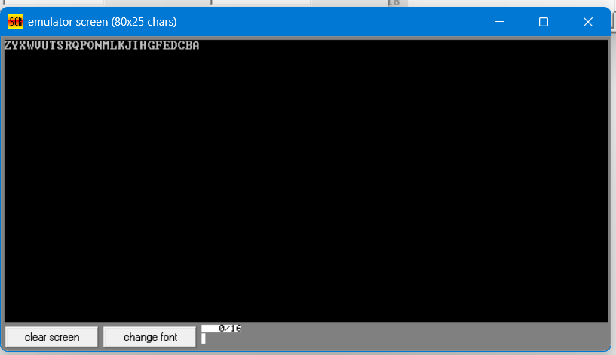

**Practice set:**

**2. (a) Write a program in assembly language to print the numbers from 0 to 9 in reverse order.**

**//CODE//**

ORG 100h ; Set code origin to 100h for .COM program

MOV CX, 10 ; Set loop counter for 10 numbers (0 to 9)

MOV AL, '9' ; Initialize AL with ASCII value of '9'

PRINT_NUMBERS:

MOV DL, AL ; Move current number to DL for output

MOV AH, 02h ; DOS interrupt to display character

INT 21h ; Call DOS interrupt to print character in DL

DEC AL ; Decrement AL to get the previous number

LOOP PRINT_NUMBERS ; Loop until CX becomes 0

MOV AH, 4Ch ; DOS function to terminate the program

INT 21h ; Call DOS interrupt to exit

**//OUTPUT//**

**(b) Write an assembly language program to print the characters from A to Z.**

**//CODE//**

ORG 100h ; Set code origin to 100h for .COM program

MOV CX, 26 ; Set loop counter for 26 letters (A to Z)

MOV AL, 'A' ; Initialize AL with ASCII value of 'A'

PRINT_CHARACTERS:

MOV DL, AL ; Move current character to DL for output

MOV AH, 02h ; DOS interrupt to display character

INT 21h ; Call DOS interrupt to print character in DL

INC AL ; Increment AL to get the next character

LOOP PRINT_CHARACTERS ; Loop until CX becomes 0

MOV AH, 4Ch ; DOS function to terminate the program

INT 21h ; Call DOS interrupt to exit

**//OUTPUT//**

